**LAB EXAMINATION – 2 (COMPUTER NETWORKS)**

**(RA22110026050021)**

**Objective:**

Set up and configure a network topology using RIP and OSPF routing protocols in Cisco Packet Tracer. Customize the network by assigning each computer a name and an IP address using the last three digits of the roll number.

**Procedure:**

1. **Network Topology Design:**
   * **Create a topology that includes:**
     + 10-12 computers distributed across two LANs.
     + Use two switches, each connecting a group of computers in a separate LAN.
     + Two routers connected via a WAN link.
   * **Device Distribution:**
     + LAN 1: 5-6 computers connected to Switch 1.
     + LAN 2: 5-6 computers connected to Switch 2.
   * **Device Naming Convention:**
     + Each computer was assigned a name in the format: PC_RollNumber (e.g., PC_123).
2. **IP Address Configuration:**
   * **Assign IP addresses to the computers in each LAN.**
     + LAN 1: IP addresses configured with the subnet 192.168.1.0/24, where each PC's IP address ends with the last three digits of the roll number (e.g., 192.168.1.123 for PC_123).
     + LAN 2: IP addresses configured with the subnet 192.168.2.0/24, similarly using the roll number for the last octet (e.g., 192.168.2.123 for PC_123).
   * **Router Interface Configuration:**
     + Router 1 interfaces were set up with the IP address 192.168.1.1/24 for LAN 1.
     + Router 2 interfaces were configured with 192.168.2.1/24 for LAN 2.
     + The WAN link between routers used a point-to-point subnet (e.g., 10.0.0.1/30 for Router 1 and 10.0.0.2/30 for Router 2).
3. **Routing Protocols Configuration:**
   * **Configure RIP v1 on Router 1:**
     + Added the network commands for 192.168.1.0 and 10.0.0.0 to enable RIP routing.
   * **Configure OSPF on Router 2:**
     + OSPF was set up using the area 0 configuration.
     + Added network commands for 192.168.2.0 and 10.0.0.0.
   * **Ensuring Communication:**
     + Verified that the routes were properly advertised and shared between the two routing protocols using route redistribution.
4. **Packet Tracer Configuration Steps:**
   * **Add Devices and Create Connections:**
     + Placed all computers, switches, and routers in the workspace.
     + Connected devices with appropriate cabling (copper straight-through for computers to switches and serial connections for routers).
   * **Configure IP Addresses:**
     + Manually set IP addresses for all computers and configured default gateways.
   * **Set Up Routing:**
     + Enabled RIP on Router 1 and OSPF on Router 2.
     + Configured route redistribution on both routers for seamless communication.
   * **Verification:**
     + Used the ping command to test connectivity between LAN 1 and LAN 2.
     + Verified route tables on both routers to ensure correct route advertisement.
5. **Simulation:**
   * **Cisco Packet Tracer Simulation Mode:**
     + Switched to simulation mode to observe packet transmission.
     + Initiated message sending from a computer in LAN 1 to a computer in LAN 2.
     + Verified the successful transmission of the message and inspected routing paths.
6. **Documentation and Submission:**
   * **Procedure Documentation:** Step-by-step process of network configuration was documented as described above.
   * **Screenshots:** Added all relevant screenshots, covering network design, IP configurations, and successful message transmission.
   * **Packet Tracer File:** Saved the .pkt file with the completed configuration.
   * **GitHub Submission:** Uploaded all documents, screenshots, and the .pkt file to a GitHub repository named "Lab 2 Exam".
   * **Repository Submission:** Submitted the GitHub repository link to the instructor.

**Output Screenshot:**

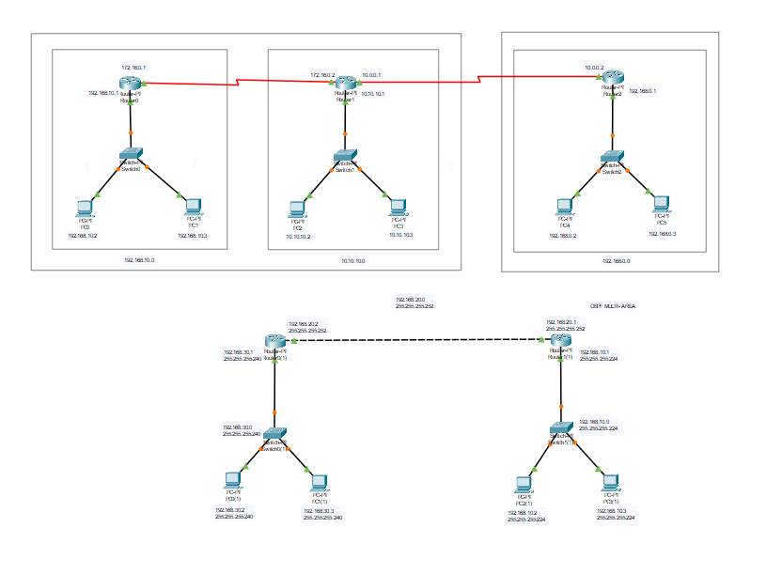

**Results:**

* Successfully configured a network topology with two LANs using RIP and OSPF routing protocols.
* All devices were assigned IP addresses based on the last three digits of the roll number, maintaining the required subnet structure.
* Routing protocols were configured on the routers, allowing seamless communication between LAN 1 and LAN 2.
* The simulation mode in Cisco Packet Tracer demonstrated successful packet transmission across the network.
* Documentation and files were submitted as per the requirements.

Name: G.Prasanna Venkatesh

Class: CSE AIML -B

Reg.No: RA2211026050021

Github Link: <https://github.com/prasannavenkatesh12>